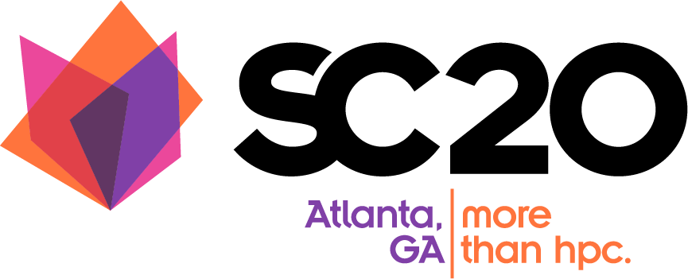

SC20 SCinet Contributor Program Participation Guide

Prepared by: SC20 SCinet Management Team
Version 1.0
4/15/20

Table of Contents
Table of Contents 1
Introduction 2
Summary of Requirements for Participation 2
Important Dates 2
Check the SCinet Contributor Portal for Updates 2
Communicate with SCinet 3
SCinet Contributor Program 4
Contributor Benefits 4
Benefits per Level 4
Exclusive Premier Benefits for Diamond and Platinum only 5
Contribution Requirements per Level 6
Preliminary Requirements and Level Assignment 6
Final Requirements and Benefits Level Assignment 6
Extra Mile Contributions 7
Volunteer Travel Support Fund 7
SCinet Co-branded Apparel 8
Definitions 8
Loaned Hardware/Equipment 8
Software 8
Services 9
Time 9
SCinet Terms 9
Forecasted Equipment List (FEL) and Bill of Materials (BOM) 9
Liability Waiver 10
Logistics 12
Insurance 12
Receiving and Inventory 12
Shipping 12
Inbound Shipping 12
Outbound Shipping 13
Visibility and Marketing 14
Logos 14
SCinet NOC Wall Panels 14
Marketing & Communications 15
SCinet Interactive Experience (SIE) Kiosk – Electronic Visualization of SCinet 15
SCinet Co-branded Apparel 16
Graphic File Formats 17

Document History
Version | Date | Comments
1.0 | May 5 2020 | Initial Publication

Introduction
SCinet contributors play a critical role in the overall success of the SC conference, without their generous support of time and resources SCinet cannot create and build the network. In recognition of this strategic partnership, SCinet has formalized the relationship within the conference structure to increase the visibility of SCinet participants and their valuable contributions to the success of the event year after year.

This document will codify the relationship between SCinet and its many contributors by documenting our activities, requirements, and expectations, along with the benefits of participation. In the following sections you will find the details necessary to fully participate with SCinet.

For additional and updated information, please check the SCinet Contributor Portal site frequently.

Summary of Requirements for Participation
Participating Contributor Deliverables:
- Formal acknowledgement of participation
- Detailed List of contribution(s) including MSRP and Insured/Replacement value via a Forecasted Equipment List and final Bill of Materials
- Signed Liability Waiver
- Shipping tracking numbers
- Outbound shipping information
- Marketing information - logo, images, custom artwork, etc.
- Contact information -please provide names, email address and phone number for the following:
  - Technical staff - assist our technical teams with the use of their hardware and/or software
  - Marketing and communications staff - assist with logo collection, news releases, blog postings, and other public-facing aspects of the contribution
  - Executive sponsorship of the effort for updates and recognition of the contribution

Important Dates

Check the SCinet Contributor Portal for Updates
Contributor Deadlines (dates are approximate and subject to change):
- Contributor Intent to Participate due Friday, June 19, 2020
- Forecasted Equipment List & Liability Waivers due Friday, July 24, 2020
- Volunteer Travel Support Fund Contribution Declaration Friday August 7, 2020
- Co-branded Apparel commitment deadline Friday, August 7, 2020
- Contributor Logos submitted Friday, August 21, 2020
- SCinet Interactive Experience Kiosk content submitted Friday, August 28, 2020
- Wall Panel Artwork submitted Friday, September 25, 2020
- Loaned Equipment Received Friday, October 9, 2020
- Network connection transfer request submitted Friday, October 16, 2020
- Request complimentary exhibits badges Friday, October 16, 2020
- Co-branded Apparel Shipment Received Friday, October 16, 2020
- Outbound Shipping Paperwork Submitted Friday, November 13, 2020

SCinet Deadlines:
- Confirmation to contributors of Benefit Level Achieved Friday, August 21, 2020
- Apparel Sizes and Quantities Released to contributors Friday, September 4, 2020
- Valuation Change Deadline Friday, October 16, 2020
- Freeman Outbound Shipping Date Saturday, November 21, 2020

SCinet ‘Terms’
The use of a “Term” is an indication of a period of time during which SCinet requires support and is the measure of time utilized when evaluating the ‘Time’ contribution.
- Planning Operations (planning meetings (onsite and virtual) and other related activities that begin early in the year and culminate before the Staging event)
- SCinet Freight Load-in (October 11th) ** Note early date
- SCinet Staging (held October 23 - November 1, ~10 days)
- SCinet Setup (held November 9-15 , ~7 days)
- SC Show and Teardown (held November 16-20 , ~5 days)

Communicate with SCinet
SCinet suggests several communications methods for contributors to use:
- General questions related to your SCinet participation: contributor-relations@scinet.supercomputing.org
- Technical questions: team-leads20@scinet.supercomputing.org
- Communications and marketing: communications-team@scinet.supercomputing.org
- SCinet management: mgmt20@scinet.supercomputing.org

SCinet Contributor Program
The SCinet Contributor Program is a framework to recognize the generous contributions of resources and effort from our partners with exclusive appreciation within the SC Conference. The program specifically outlines the types of contributions necessary to reach defined levels of benefits. Contribution levels are applicable to hardware, software, and service providers that directly donate their time and materials to SCinet. Contributing organizations must formally acknowledge their participation to the SCinet Contributor Relations team or their Technical Team in order to be eligible for all aspects of the program.

Contributor Benefits

Benefits per Level
Each classification level provides a set of benefits for the contributor in recognition of the support provided to SCinet in the form of equipment, software and services. For all tiered items listed in the table below (flyers, web pages, banners), a higher tier represents more prominent placement and size of logo. Network connections are transferable to other booths upon request. Items including exhibit badges, space selection, or items provided via external parties are not transferable. Many items have an associated deadline.
Benefit | Diamond | Platinum | Gold | Silver | Bronze
Network Connection | Free Connection of Choice | Free Connection of Choice | Free 1Gb/s or 10Gb/s, or Discounted 100Gb/s  Or  2 additional exhibits badges | Free 1Gb/s or 50% Discounted 10Gb/s  Or  1 additional exhibits badge | 50% Discounted 1Gb/s  Or  1 additional exhibits badge
Exhibits Badges | 5 | 4 | 3 | 2 | 1
Logo on NOC Banner | 1st Tier | 2nd Tier | 3rd Tier | 4th Tier | 5th Tier
Logo Placement on Display Panels | Guaranteed Front of NOC placement | Guaranteed Side of NOC placement | Guaranteed Side of NOC placement | NOC or DNOC placement | DNOC placement
Customized Wall Panel | Guaranteed NOC placement | Guaranteed NOC placement | NOC or DNOC | N/A | N/A
Logo and Mention during SC General Chair Keynote | Yes | Yes | N/A | N/A | N/A
SC Blog Post Highlighting Diamond Contributors | Yes | N/A | N/A | N/A | N/A
SCinet Contributor Web Page and Attendees Flier | 1st Tier | 2nd Tier | 3rd Tier | 4th Tier | 5th Tier
SCinet Interactive Experience Kiosk | Yes | Yes | Yes | Yes | Yes
Assistance in SC21 Exhibitor Booth Selection | Yes | Yes | N/A | N/A | N/A
SCinet Premier Benefits | Select 2 | Select 1 | N/A | N/A | N/A

Exclusive Premier Benefits for Diamond and Platinum only
Contributors that reach the Diamond or Platinum level are given the option of selecting exclusive benefit options. This program is designed to allow greater flexibility in supplying the items that matter most to our most important contributors.

Premier Benefit | Diamond | Platinum
Diamond level participants can pick 2 of the items below. Platinum level participants can pick 1 of the items below.

Network Connection | Additional Free Network Connection of Choice | Additional Free Network Connection of Choice
Additional Exhibitor Staff Badges | 5 | 4
Communications Assistance | 1) Advanced access to conference media list  2) Quote from the SCinet Chair for use in contributor press release | Advanced access to conference media list
Exhibitor Suite | 100% of Space Discounted | N/A

Contribution Requirements per Level

Preliminary Requirements and Level Assignment
SCinet management and team leads evaluate the Forecasted Equipment List (due in July and used to provide insurance information to the SC sponsoring organization) to determine the contribution value and corresponding time requirements of the contributions. Information submitted after the deadline may not be eligible for all benefits. A preliminary ‘contributor benefits level’ (Bronze, Silver, Gold, Platinum, and Diamond) will be assigned based on the total Forecasted Equipment List ‘Insured or Replacement Value’ and guidelines listed in the charts below.

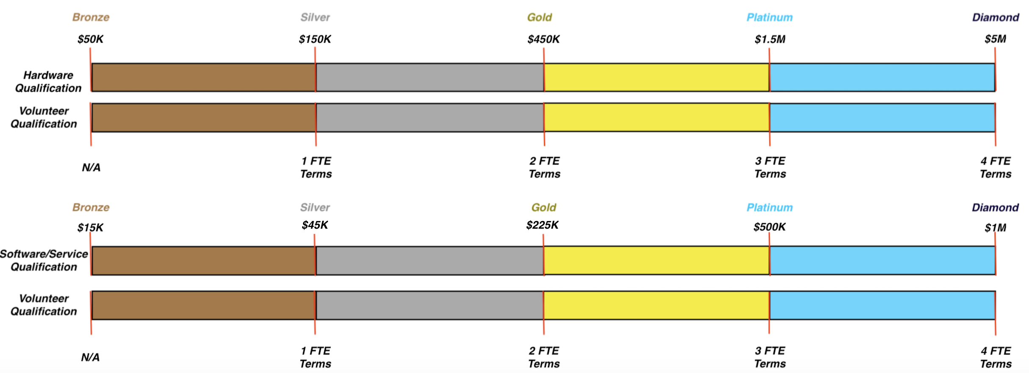

Final Requirements and Benefits Level Assignment
The Final Contributor Benefits Level will be assigned closer to the SC conference and take into consideration changes in valuation due to BOM modifications and participation in Contributor Benefits Program Extra Mile items such as Volunteer Support or SCinet Co-branded Apparel. Changes in valuation due to increases through the Extra Mile programs or reductions in contribution will be addressed when they occur.

It is recommended that SCinet teams and their contributing partners communicate regularly to ensure an accurate Forecasted Equipment List and subsequent Bill of Materials that reflects the hardware, software, or services that will best showcase and support SCinet.

The following table indicates the support required to reach each level. Please note the groupings associated with the contributions as they define the framework of meeting the requirements of a particular level.

 | OR |  | OR |  | Extra Mile Choose One
Level | Hardware | Software/Services | Time (Term) | Travel Support | Travel Support | Shirts
Diamond | $5M | $1M | 1 FTE x 4 Terms | $15K | N/A | N/A
Platinum | $1.5M | $500K | 1 FTE x 3 Terms | $10K | $15K | Higher-quality apparel (e.g. outerwear or button-up shirt)
Gold | $450K | $225K | 1 FTE x 2 Terms | $5K | $10K | Button-up or Polo
Silver | $150K | $45K | 1 FTE x 1 Terms | $2,500 | $5K | Polo or Long Sleeve T-shirt
Bronze | $50K | $15K | N/A | N/A | $2,500 | T-shirt, or branded merchandise (hats, tote-bags, etc.)

As an example, if a contributor has contributed $200K in hardware and is sending a technician for either staging or setup activities, they have a base qualification for the “Silver” level. To jump to the gold level, a contribution of $5K to the travel assistance fund can be made or the contributor can provide SCinet Co-Branded Apparel, such as a Polo or Long Sleeve T-shirt.

Extra Mile Contributions

Volunteer Travel Support Fund
Contributions to the travel support fund assist SCinet Volunteers who wish to volunteer their time and expertise to SCinet, but are not able to secure complete funding from their home institution. Volunteer Travel Support Fund recipients may receive travel expense assistance for airfare, lodging, ground transportation, and per diems. Although donors to this fund do not have control of the selection process, SCinet will make efforts to ensure that contributors are properly recognized for their contribution to the SCinet mission.

Contributions to the fund must be declared to the SCinet Chair or Management team by the defined deadline and will be made via the Hall Erickson exhibitor system.

SCinet Co-branded Apparel
Contributions to the SCinet Co-branded Apparel program provide another way to publicize a contributor’s participation and help a contributor achieve the next level of benefits. See more information about the program in the SCinet Co-branded Apparel program section.

Definitions

Loaned Hardware/Equipment
Loaned equipment refers to physical hardware loaned, directly from the contributor, to SCinet for the duration of SC20 activities. This is defined to start at the October freight load-in event through the November teardown, or at other times throughout the year for evaluation and testing activities. Equipment intended for use during the Show must arrive at the designated time (see the Logistics section below for details).

The valuation is tied to the Insured or Replacement Value submitted as part of the Forecasted Equipment List and Bill of Materials (BOM). Loaned equipment requires a pairing with a Time contribution, defined in the following section.

We require the contribution of “time”, as it is used to offset the installation, configuration, operation, and maintenance of the hardware. If hardware does not come with a matching donation of time, the classification will be valued at the lower of the two contributing factors. The level accepted by SCinet is up to the discretion of the team utilizing the hardware and is approved by the SCinet Chair.

SCinet will attempt to install all loaned equipment in the NOC or DNOC racks visible on the exhibits floor. In some cases, certain hardware might be physically installed in a location that is not visible to show attendees. In these cases, SCinet will attempt to accommodate vendors as much as possible, such as installing a non-functional unit in the NOC racks, printing a picture of the device on a blank NOC panel, or having a vendor’s logo on a filler panel in a rack.

Software
Software refers to standalone products, other than firmware and operating systems required for operation of loaned equipment or services. The software must play a substantive role within the SCinet architecture, or be aligned with one of the technical teams, to be considered for the program.

The value associated with the software loan is based on the Insured or Replacement value for the level of software utilized by SCinet, prorated for the period of use (e.g. 1 month), to ensure a leveling comparison against the contribution of hardware or services in order to provide equitable levels of contributor classification.

We require the time component, as it is used to offset the installation, configuration, operation, and maintenance of the software. If software does not come with a matching contribution of time, the classification will be valued at the lower of the two contributing factors. The level accepted by SCinet is up to the discretion of the team utilizing the hardware and is approved by the SCinet Chair.

Services
Services are neither loaned equipment nor software, but provide a function critical to the operation of SCinet. Common examples are dark fiber, bandwidth access, colocation services, interconnects, etc. These services may only be provided by the organization owning the service in question, and not re-sellers or suppliers. Services are accepted and valued based on published rates/pricing prorated for the period of use.

We require the time component, as it is used to offset the installation, configuration, operation, and maintenance of the service. If a service does not come with a matching contribution of time, the classification will be valued at the lower of the two contributing factors. The level accepted by SCinet is up to the discretion of the team utilizing the hardware and is approved by the SCinet Chair.

Time
Time contributions in the form of technical support for contributed items (hardware, software, and/or services) will be calculated using the traditional “FTE” (full-time-equivalent) nomenclature. Individuals must actively participate in the design, build, or support process in order to meet the requirements. Support for the event is a priority during key times of the year, however, technical support assigned to SCinet may still work on ‘day job’ activities as needed.

Alternative requirements may be used to reach the desired benefit level at the discretion of the SCinet Chair. For example, certain products such as remotely operated software and services, will not need support staff on-site to ensure proper operation. Contributors are still encouraged to name specific remote staff SCinet can work with, and this can be used as “credit” for the time commitment requirement. These types of circumstances will be evaluated on a case-by-case basis.

Additionally, a contributor may offer to fund a volunteer via the Volunteer Travel Support Fund to offset the time contribution, if they cannot spare staff time to assist for the duration of SCinet activities.

SCinet Terms
The use of a “Term” is an indication of a period of time during which SCinet requires support.

- Planning Operations (planning meetings (on-site and virtual) and other related activities that begin early in the year and culminate before the Staging event)
- SCinet Pre-Staging (October 11-13, 3 days)
- SCinet Staging (October 21-30, ~10 days)
- SCinet Setup (November 9-15 , ~7 days)
- SC Show and Teardown (November 16-20 , ~5 days)

Forecasted Equipment List (FEL) and Bill of Materials (BOM)
FEL - The Forecasted Equipment List is due to SCinet in early August (see Important Dates) and includes a detailed description of the estimated contribution to SCinet. The FEL serves two purposes:
- Evaluation and designation of Preliminary Contributor Benefit Level
- Insurance value of contributions to be insured by SC - Using the Forecasted Equipment List, the conference sponsors (IEEE and ACM) will secure insurance to cover the replacement cost of the equipment loaned by each contributor for the period which SCinet has possession of the equipment. It is critical that the Forecasted Equipment List be submitted on time and must accurately depict what is being sent, and will be used, by SCinet.

BOM - The Bill of Materials may have several iterations with the final BOM due to SCinet in mid-September (see Important Dates). The BOM serves two purposes:
- This detailed contribution list provides the roadmap for SCinet architecture, services and support
- Evaluation and designation of the Final Contributor Benefit Level

Format
The Forecasted Equipment List and final BOM must include the following details:

- Company Name and Point of Contact (POC)
- Address & contact information for Contributor POC (contact Name, email, and phone number)

For each item loaned, we require the following:
- Part number (P/N) used by the contributor (not a reseller or supplier)
- Description of the part in question
- Quantity provided
- Insurance or replacement value (used for benefit valuation)
- Optional MSRP (30% of MSRP will be used if insured value is not supplied).

SCinet recommends submitting these materials in an easily readable and consumable format such as a spreadsheet. Other formats (PDF, DOCX, etc.) are acceptable, but do not facilitate easy translation of content to our internal formats.

If you do not have a set BOM format, a sample can be downloaded from this location:

https://scinet.supercomputing.org/contributor-relations

Submission
FELs/BOMs and waivers will be accepted via the logistics@scinet.supercomputing.org mailing list and must include all the details listed above. Submissions will be carefully controlled and not shared outside the needed personnel. In instances where additional equipment is shipped for replacements or augmentation, updates must be sent to the same list to ensure that we have proper insurance coverage for equipment.

Liability Waiver

All contributors providing hardware are required by the sponsoring societies to submit a completed insurance liability waiver.

You can download the SCinet Liability Waiver here: https://scinet.supercomputing.org/contributor-relations

Logistics

Insurance
Using the Forecasted Equipment List, provided by the contributor, the conference sponsors (IEEE and ACM) will secure insurance to cover the replacement cost of the equipment loaned by each contributor for the period when SCinet has possession of the equipment. It is critical that the Forecasted Equipment List be submitted on time and must accurately depict what is being sent, and will be used, by SCinet.

Receiving and Inventory
When the equipment is received, the Bill of Lading (BOL), or the results of the check-in process, will supersede the BOM as the basis for inventory and accounting of received items as well as the inventory operations used for returning the correct materials at the end of the conference. Differences between BOL and BOM will require a signature by representative of the contributor or SCinet team lead. If the replacement cost is not specified on the BOM, or the BOL differs significantly from the BOM, SCinet may not be able to properly determine the insurance value of the equipment and can NOT be held liable if an adequate insurance level is not obtained.

Shipping
Shipping of equipment for use within SCinet must be coordinated with the Logistics team.

Inbound Shipping
Shipping will be categorized into two time periods:

- Items required for the Pre-staging event in October (most common)
- Items arriving for the Setup/Show event in November (least common)

The shipping label must be applied to each and every box, envelope, crate, etc that will arrive for staging.

Additionally, tracking information for each shipment must be shared with logistics@scinet.supercomputing.org. This allows the logistics team to identify shipment for routing within the Freeman shipping yard, locate missing items and ensure that all items arrive at the convention center on-time for staging, setup and show. All loaned equipment and other materials must be delivered, using the Freeman label, by the defined deadline.

In all cases, the Bill of Lading (BOL) will be used to inventory the equipment as it arrives and will be presumed to supersede the equipment list from the BOM for insurance purposes. Any discrepancies between the BOL and the received equipment as inventoried will be noted and communicated to the contributor.

Items being shipped later should use the same label and procedure above, noting to Logistics expected arrival time.

Outbound Shipping
In all cases, unless discussed and approved by the SCinet chair, SCinet will unrack and repack loaned equipment using the materials used for inbound shipping. If a contributor desires to have their staff involved with the unracking and repacking, this must be declared to SCinet as part of the shipping choice selection. In NO case, however, will equipment be released from SCinet possession without a completed outgoing inventory and signature to confirm handoff.

It is critical to ensure that your return shipping choices are made by the deadline date. Changes may be made after the deadline, and will be fulfilled where possible, but cannot be guaranteed. Shipping to residential addresses is complicated due to common carrier restrictions. When designating the destination address, it is recommended to utilize a commercial address.

Steps to ensure the secure and proper return of your equipment

- Complete and submit the SCinet Outbound Shipping Request. Select the appropriate shipping method.
- Complete and submit appropriate Freeman shipping paperwork.
- Complete and verify, via signature, the proper packing of your equipment (optionally completed by SCinet)
- International shipping (by it’s nature) is slower than domestic shipping. Customs forms will be available from Freeman.

Shipping Process

Freeman will organize and ship your equipment to the chosen address(es) as identified in the submitted Freeman paperwork. SC insurance will cover the equipment until delivered to designated destination.

Exceptions:
- Hand carry - with coordination you may hand carry/roll your equipment back to your booth for shipping with the rest of your company’s equipment or to a private carrier. Once signed out, SC insurance no longer covers the equipment.
- Ship by chosen carrier - with coordination, you may choose a private carrier for your shipping needs. Freeman will release the equipment to the carrier when they arrive. Because Freeman manages the logistics for the convention center, private carriers are often a slower choice. Please keep this in mind as you schedule your pickup, and it may be the case that the carrier does not receive access to dock infrastructure until a later time. SC insurance covers the equipment until accepted by the private carrier.

Regardless of selected shipping method, access to loaned equipment is restricted after the show closes until it has been successfully cleared by the SCinet Logistics team by representative signature. During SCinet activities (beginning upon receipt by Freeman and terminating with the release of the equipment to the owner, which varies by shipping method) SC has insurance liability for the equipment until this process is completed. Please be patient and understand that we are completing a complex process that cannot be rushed. It is our goal to return all aspects of the loaned equipment in the same shape it arrived, thus our care is warranted to ensure safe and accurate delivery.

Visibility and Marketing

Logos
High-quality (vector scalable) logo images are used on our banners, panels, press releases and web presence. Timely access to contributor logos allows us to design visual branding which provides the highest visibility to our contributors.

Failure to submit a high quality logo will result in exclusion from the banners, panels, press releases and web presence. See the File Format section that follows for details on acceptable options.

SCinet NOC Wall Panels
Continuing the tradition started in Dallas at SC2000, SCinet will prepare and display on wall panels around the NOC. Contributors that reach the Diamond, Platinum, or Gold level of recognition have the option of submitting special advertising graphics. Each wall panel is 1 meter wide by 3 meters tall. The actual usable space for your special advertising graphics is 32 inches wide by 48 inches high. An example wall panel follows:

A wall panel is not restricted to just contributor logo, if you there are specific advertising strategies currently in use that use other material, these graphics may be adapted and submitted. It may also make sense to make references to an SC20 booth number (such as "See us in Booth 123"), a website address, QR Code, or other information about your organization or company. Within reason, the space use is up to the contributor. The panels usually have a bright white background with accent colors from the current conference logo and may include the conference and/or SCinet logos on the top or bottom.

To a large extent, you are responsible for the quality of the final product. The following guidelines are provided to ensure that you get high quality results:

- Make sure your artwork proportions are correct to the desired final size (maximum 32 inches wide by 48 inches high), and contains proper resolution for enlargement.
- Vector file formats are required. Depending on the scale, lower resolutions may result in decreased image quality. SCinet is not responsible for the quality of submitted graphics.

Failure to submit a high quality logo will result in exclusion from the banners, panels, press releases and web presence. See the File Format section that follows for details on acceptable options.

Marketing & Communications
SCinet encourages our contributor partners to share information on their products and services during the SC20 conference. All press releases that reference contributions to SCinet and/or SC20 must be submitted to the SCinet Communications Team for review and approval prior to release. Our communications team is available to assist in this process, to ensure that contributions are being highlighted in a uniform and positive manner

The following services are offered to all contributors in the program:

- Logo recognition on SCinet web presence & conference handout
- Interactive content delivered via SCinet Interactive Experience Kiosk located at SCinet NOC
- Logo recognition on SCinet displays located in the conference exhibit hall

For our Diamond level participants, we are also pleased to offer the following services:

- Assistance in developing impactful communication strategies for contributions
- SC blog post recognizing all Diamond level contributors

More information is available via our communications team who can be reached via communications-team@scinet.supercomputing.org.

SCinet Interactive Experience (SIE) Kiosk – Electronic Visualization of SCinet
The SCinet Interactive Experience (SIE) Kiosk is an interactive tool, available to all contributors, to further educate conference exhibitors and attendees about contributor participation as well as equipment roles and activities. We provide the SIE Kiosk as an alternative to paper-based handouts of equipment. Contributors may not provide SCinet with any physical handout material for distribution under any circumstances. The SCinet Interactive Experience Kiosk technology is implemented with a touch-screen located at the NOC stage that is customized yearly. It is backed with an extensive database of images and information related to the hardware and configuration of SCinet. The information in the database is created from information provided directly by the contributors. An example photo of the SIE Kiosk being utilized by an SC attendee follows:
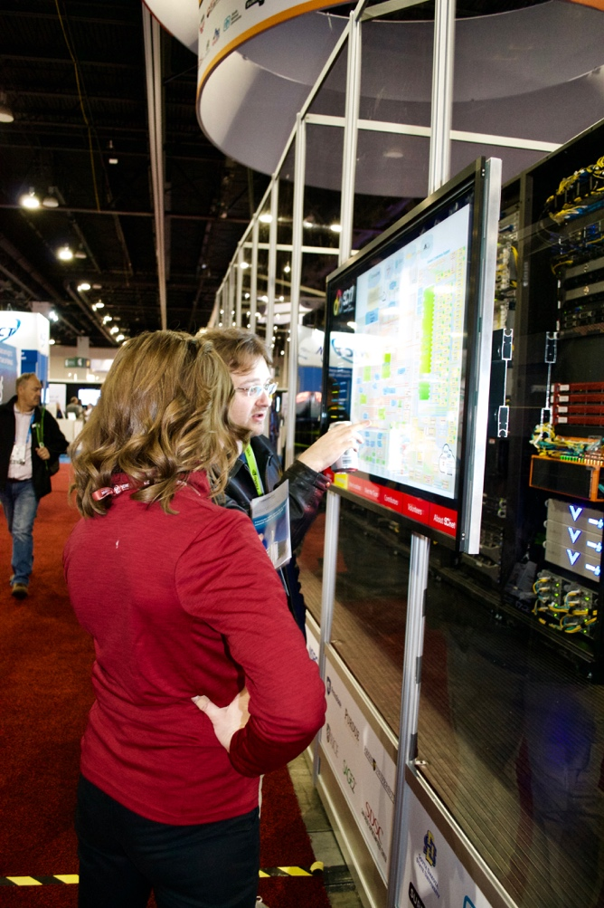
In order to provide the best experience, we ask that all images and text be submitted by the defined deadline. This allows our SIE Kiosk team to create and test the tool to ensure proper operation. Failure to meet this deadline will result in stock images being inserted and no pop-up information being available to exhibitors and visitors.

To participate, provide the following information:

- High quality images of loaned equipment (switches, routers, appliances, servers, etc.)
- Text-based description of their role, operational specifics and marketing details (plain text file)
- Links to online resources that can be followed for more information
- Indication of booth (if applicable) where more information can be found on the show floor

See the File Format section that follows for details on acceptable options.

SCinet Co-branded Apparel
SCinet Co-branded t-shirts, polos, vests, and outerwear are another way to publicize a contributor’s participation. SCinet will provide the following details:

- SCinet Logos and thread colors (these are non-negotiable and change each year). Use of prior year threadwork is not permitted, please be careful not to accidentally reuse a previous year’s logo or colors, this will disqualify apparel from being able to be used during the conference
- Sizes and quantities for SCinet use
- Restrictions on logo placement on the article
- Historical size baselines for planning purposes
- Suggested colors to prevent conflict with other items
- Suggested days and opportunities the articles can be used

SCinet will provide the size quantities to the contributors who have elected to donate apparel no later than early September. SCinet management should be consulted on all designs before they are finalized to verify coloring and logo placement. Delivery is required by the defined shipping deadline. Please use the logistics label.

Once received, the apparel will be sorted and provided to SCinet team members. Coordinated schedule of use during the event will be provided prior to show week. Preference for a particular day may be considered. Conflicts over days will be broken by contributor level and decided at the discretion of the SCinet Chair.

Graphic File Formats
It is extremely important to submit your organization or company logo in a format appropriate for scaling up on print and embroidered products. The preferred file formats are the vector formats listed below. The raster formats are normally unacceptable, unless the logo is developed for a large-scale printout. Graphics submitted in a compressed raster format will be rejected and will not be included in the banner if our graphics team deems them unacceptable. See the table below for clarity. Vector images are preferred and will be verified by the graphic design team.

Extension | Description | Type
EPS, PS | Encapsulated & PostScript | Vector
AI | Adobe Illustrator | Vector
CDR | Corel Draw | Vector
CMX | Corel Presentation | Vector
PDF | Adobe Acrobat | Vector
SVG | Scalable Vector Graphics | Vector
JPG/JPEG | JPEG | Raster
TIF/TIFF | Tagged Image File Format | Raster
CPT | Corel Photo Paint | Raster
PSD | Adobe PhotoShop | Raster
PNG | Portable Network Graphics | Compressed Raster
GIF | Graphical Interchange Format | Compressed Raster
BMP | Bitmap | Compressed Raster
Any formats not listed above cannot be accepted.

SCinet is unable to recognize suppliers as a part of this process, and will only be able to convey the benefits of the program to our direct contributor contacts.
Network connection is transferable to a booth designated by the Contributor. Selection or transfer must be made by the defined deadline
Must be identified by the defined deadline. Badges are assigned to specific attendees for the duration of the event.
Company and Equipment included and displayed next to SCinet NOC on Exhibit floor. Note this is electronic, and no paper copies will be accepted for display.
Early selection of booth space for SC21 with proximity to SCinet NOC (during space selection process at SC21). Benefit is for preference only, and contributor is responsible for cost of booth space. This benefit is non-transferable and in collaboration with Exhibits operator (Hall Erikson).
Network connection is transferable to a booth designated by the Contributor. Selection or transfer must be made by defined deadline
Must be identified by defined deadline. Badges are assigned to specific attendees for duration of event.
Benefit will allow contributor free or discounted purchase of an Exhibitor Suite on the SC21 Exhibit floor. Benefit is non-transferable. Benefit does not include additional modifications to whisper suite (e.g. furniture, furnishings, network connectivity) it is space ONLY.
Note that the Diamond level is only available to two total contributors: one from the hardware area, and one from the service/software area.
Allows for a contributor to achieve the next classification level. Either additional donation to volunteer travel support fund or donation of SCinet Co-branded Apparel meet the requirements.
Note that only two total contributors can qualify for Diamond. One from the hardware area, and one from service/software area.

